**Power BI Dashboard Explanation**

**Dashboard Topic :** Zomato Dataset Analysis

**Count of Dashboard** : 4

**Understanding about the topic :** Zomato is a food delivery and restaurant discovery app that helps users find nearby restaurants, read reviews, and order food online. It connects customers, restaurants, and delivery partners to make food ordering fast, easy, and reliable.

**Problem Statement :** With the rapid growth of online food delivery, Zomato faces challenges in managing high order volumes, ensuring timely deliveries, maintaining customer satisfaction, and helping restaurants optimize their operations. Analyzing Zomato's data is essential to identify trends, improve delivery efficiency, and enhance overall user experience.

**Solution :** To address the issues of high order volumes, delivery delays, customer satisfaction, and restaurant performance, Zomato can implement a **data-driven analytics solution** using **Power BI.** To gain insights and optimize operations.

**Final Outcome**

* Reduced delivery times and better logistics
* Increased customer satisfaction and loyalty
* Improved restaurant efficiency
* Better decision-making using real-time visual insights

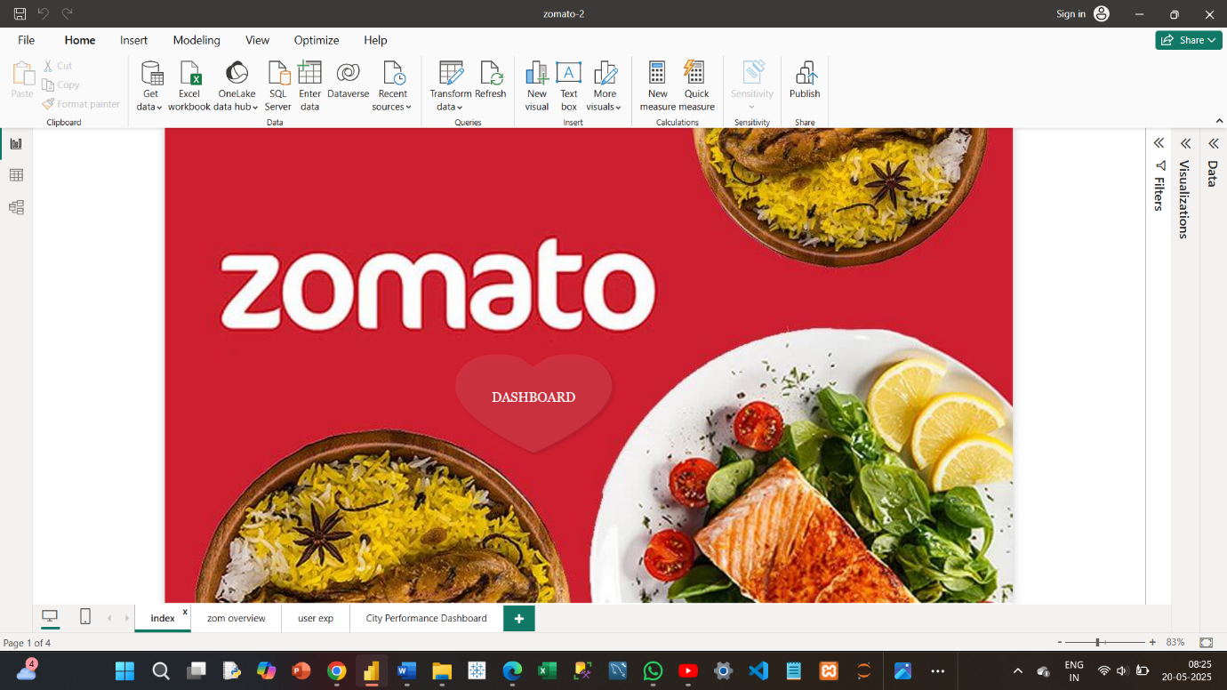

Index page which navigate to the next page while touching the “DASHBOARD” button.

Index page has the image followed by the Zomato …

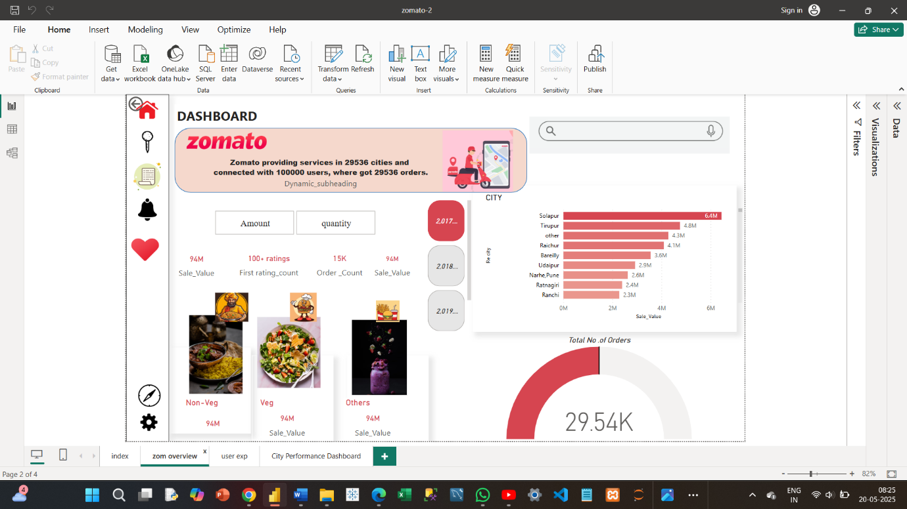

FILTERS

KPI’S

Visualization : **clustered Bar Chart**. Displays the city along with the city name and axis type

Dashboard page which displays the overview of the **ZOMATO**

YEAR WISE FILTER UPTO 2017,2018,2019,2020

Image displays about the Zomato with filter like **VEG , NON-VEG , OTHERS**

**GUAGE** visualization tells the **TOTAL NUMBER OF ORDERS.**

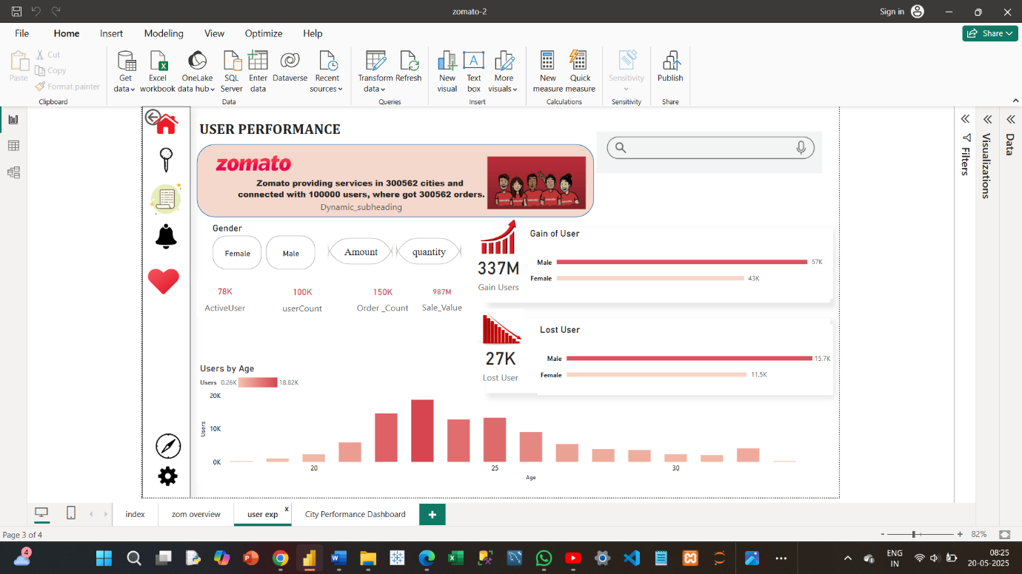

Image of the Search Bar

KPI’S

FILTERS

**clustered column chart** which displays the **average age of the user**

TOTAL NUMBER OF USERS **GAIN AND LOSS**

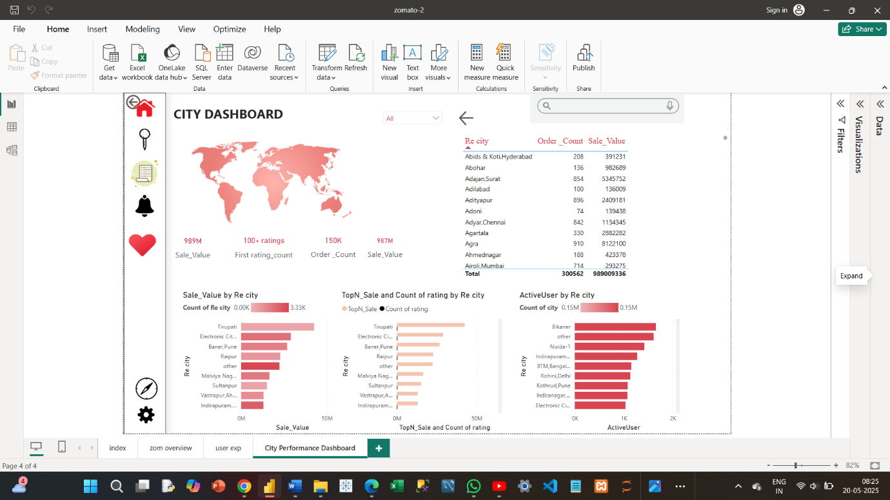

It is a filter which will show all the name of the city and user can easily search the required city with this filter

KPI’S

A table has a city and order’s count and sales value alone the **total**

Clustered row chart : which has three kind of displays

1: Sales value by city

2: Count of rating by City

3: active users by City

Image visualization like a application setup or website home page